LICHTGITTER -
QUALITY SINCE 1929

I li t tt

TABLE OF CONTENT

Lichtgitter presentation
Products
+ Gratings
+ Perforated metal planks
+ GRP-Products
+ Spiral Staircases
Applications
+ Architecture
+ Storage and Logistics
+ Offshore

A BRIGHT OUTLOOK SINCE 1929

LICHTGITTER WAS ESTABLISHED IN 1929 IN ORDER TO CARRY OUT THE SPECIALIZED MANUFACTURING OF
GRATINGS.

By the continuous monitoring of our performance, and quality
systems, together with innovation in manufacturing techniques, we have ensured Lichtgitter’s place in the forefront of manufac- turers of industrial floor coverings with subsidiaries all over the world.
Apart from the use in the industrial and construction sector,
gratings are also increasingly used in architectural applications. Whether as facade gratings, sun protection gratings, ceiling grids or as walkways or platforms, there are no limits to the use of
gratings.

Besides the production of pressure-locked gratings, forge-welded gratings and perforated metal planks, a various offer of GRP pro- ducts are part of the production range. Our current product range also includes profiled chequer plates, spiral staircases, stairtreads and ladder rungs. Together with our steel service centre powder coating and hot dip galvanizing plants we provide a large vertical production depth for the benefit of our customers.

FOUNDED

95EN0MATPIES

SUBSIDIARIES

MORE THAN

EXPERTS
1,500

WORLDWIDE
IN

COUNTRIES

THE LICHTGITTER GROUP

To meet the demands of our international customers and to put into effect the integration of the European and non-European
grating markets, Lichtgitter has established subsidiaries and
P R ES ENTAT ION LICHGITTER
partners, not only throughout Europe, but also worldwide. This
has formed the basis for the creation of a global network for both distribution and production outlets.
Decades of experience in manufacturing of gratings are not always sufficient in itself. Only fully verified standards and properly
followed instructions, along with further innovative development of production procedures and materials, can satisfy our client’s
demands and expectations, in respect of quality.

Certfied according
DIN EN ISO 9001:2015

OUR COMPREHENSIVE SERVICES HELP TO ACHIEVE YOUR GOALS QUICKLY. FROM THE VERY FIRST CONSULTA- TION, WE OFFER YOU COMPETENT, PRODUCT AND OBJECT-RELATED ADVICE WITH PROFESSIONAL AND TECH- NICAL KNOW-HOW.
In this way, our specialists can develop innovative solu- tions to meet your specific requirements. We are happy to assist you with your project from the planning stage
through to the preparation of installation plans and com- plete technical documentation. Packing lists, safe packing and commissioning are also part of our service.

Technical advice on the calculation and selection of our different products

Preparation of auditable static verification

Production of 2D- and 3D drawings
Preparation of
installation plans

Providing of tender documents

Measurement on-site

Appropriate packaging and consignement

Assembly for testing reasons and trainings

OUR MISSION IS AS SIMPLE AS IT IS CHALLENGING: TO PROVIDE OUR CUSTOMERS WITH INNOVA- TIVE PRODUCTS THAT MEET THE HIGHEST QUALITY STANDARDS. THIS IS WHAT OUR CUSTOMERS HAVE APPRECIATED FOR MANY YEARS.
In addition to pressure locked and forge welded gratings, our range includes perforated metal
planks, GRP products and spiral staircases in a wide variety of designs. Tailored to your needs.

PRODUCTION SITES GERMANY
SUBSIDIARIES AND PARTNERS WORLDWIDE
Lichtgitter GmbH, 48703 Stadtlohn
Austria
Bulgaria
Czech Republic
Denmark
Norway Qatar
Romania
Slovakia
Spain
Sweden
Switzerland
Turkey
United States
Lichtgitter GFK GmbH & Co. KG, 48703 Stadtlohn
Finland
Lichtgitter Blechprofilroste GmbH & Co. KG, 72172 Sulz/Neckar
France
Great Britain
Greece
Italy
Lichtgitter Treppen GmbH & Co. KG, 16278 Pinnow
Netherlands
P R ES ENTAT ION LICHGITTER

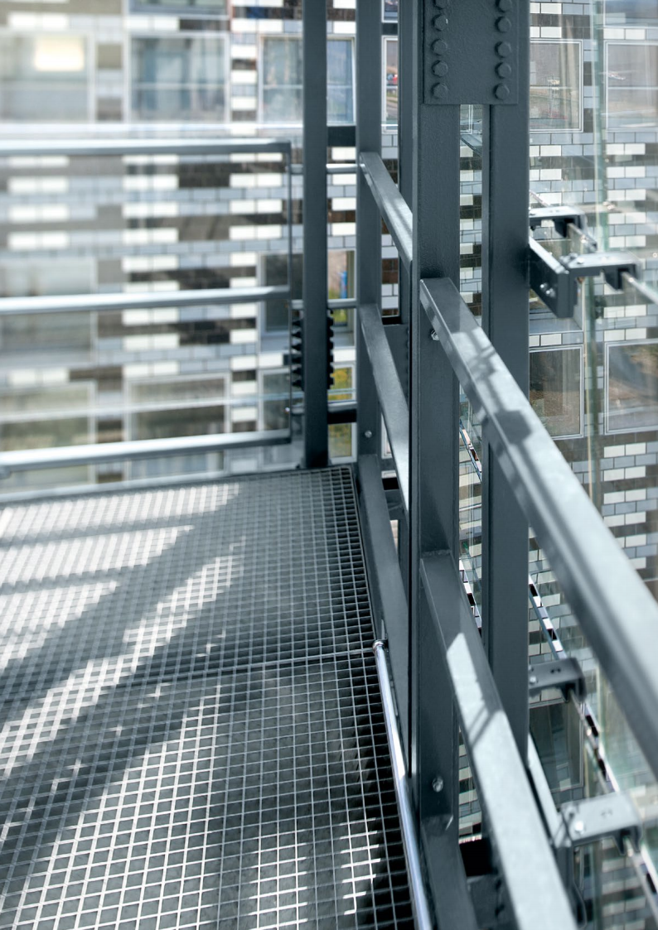

PRODUCTS
PRODUCTS

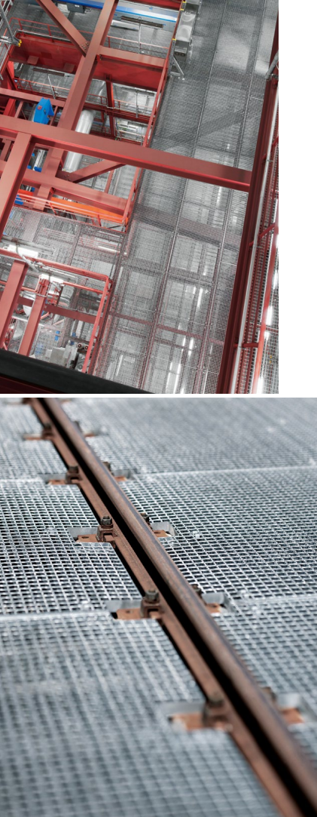

FORGE WELDED GRATINGS IN USE
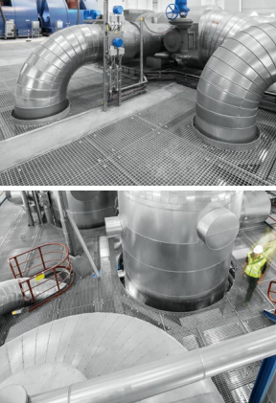

PRODUCTS

GRATINGS  FORGE WELDED GRATINGS  Forge-welded gratings consist of twisted or  round cross bars, which are pressed into the  bearing bars under high pressure. They are fully electrically welded.  Forge welded gratings are mainly used in the industrial sector as floorings, platforms and all kinds of walkways.  Decades of experience have made the Lichtgitter Group one of the world‘s leading manufacturers of forge welded gratings.  In addition to custom-made and high-quality special products, Lichtgitter also offers a wide range of industrial gratings, stair treads and panels from stock - of course also with round instead of twisted crossbars and as offshore gratings. | Forge welded grating Forge welded g rat ing w ith round Of fshore-grating  cross bars | 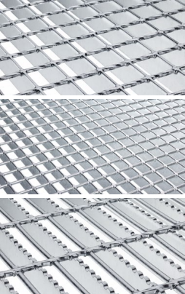

TECHNICAL DATA

Bearing bar spacing | Cross bar spacing | Bearing bar thickness | Bearing bar height
15,06 mm | 18,40 mm | 2 mm | 25 mm
16,66 mm | 19,00 mm | 3 mm | 30 mm
21,64 mm | 23,40 mm | 4 mm | 40 mm
23,69 mm | 24,00 mm | 5 mm | 45 mm
24,85 mm | 38,10 mm |  | 50 mm
30,16 mm | 50,80 mm |  | 60 mm
33,17 mm | 76,20 mm |  | 70 mm
34,33 mm | 101,60 mm |  | 80 mm
41,46 mm

All features can be combined to a certain extent with each other. Please contact us to discuss the producibility of the gratings. Our sales advisors will be happy to help.

If a slip resistance class higher than R10 is required, this
requirement is met by means of an anti-slip punched bearing bar.

PRESSURE LOCKED GRATINGS
Pressure locked gratings are used for walkways,
shelvings, platforms and cellar shafts. Due to the infinite number of variations that can be produced, this type of grating is used where architecture and aesthetics are important. Heavy duty gratings are used where extremely high loads need to be ab-
sorbed, e.g. in traffic areas.

In the manufacturing of pressure locked gratings,
unweakened cross bars are pressed into specially
slotted bearing bars at high pressure. Lichtgitter
manufactures up to 3,500 different types of pressure locked gratings made of steel, stainless steel and
aluminium on its adjustable production facilities.

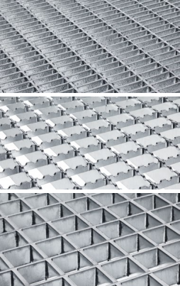

C lose- meshed pressure locked
gratings
Pressure locked grating anti-slip Heavy duty gratings

TECHNICAL DATA

Bearing bar spacing | Cross bar spacing | Bearing bar thickness | Bearing bar height
22,22 mm | 11,11 mm | 2 mm | 25 mm
33,33 mm | 16,66 mm | 3 mm | 30 mm
44,44 mm | 21,00 mm |  | 35 mm
66,66 mm | 22,22 mm |  | 40 mm
 | 33,33 mm |  | 45 mm
 | 44,44 mm |  | 50 mm
 | 66,66 mm |  | 60 mm
 | 100,00 mm |  | 70 mm

All features can be combined to a certain extent with each other. Please contact us to discuss the producibility of the gratings. Our sales advisors will be happy to help.

If a slip resistance class higher than R10 is required, this require- ment is met by means of an anti-slip punched bearing bar.

PRODUCTS
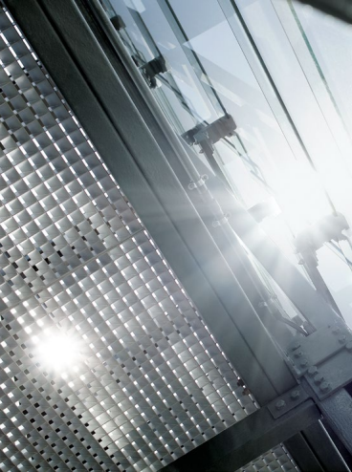
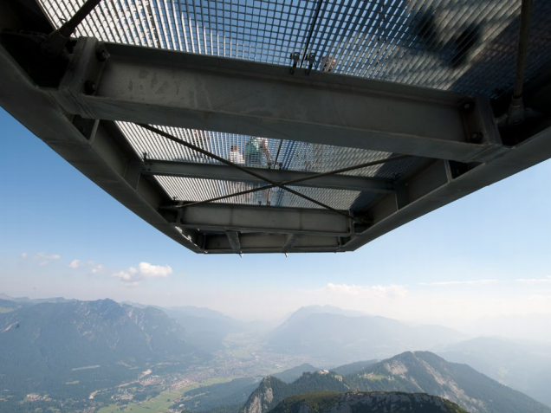
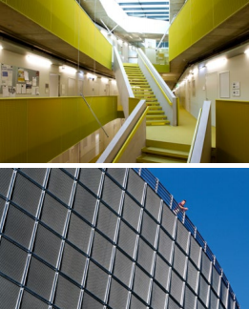
PRESSURE LOCKED GRATINGS
IN USE

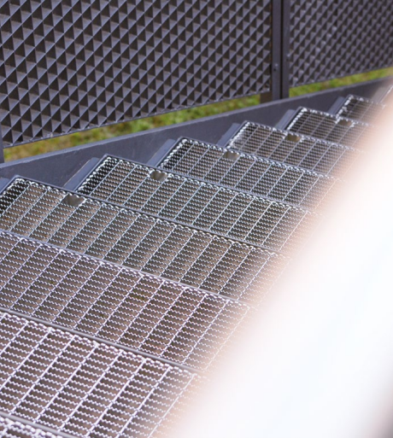
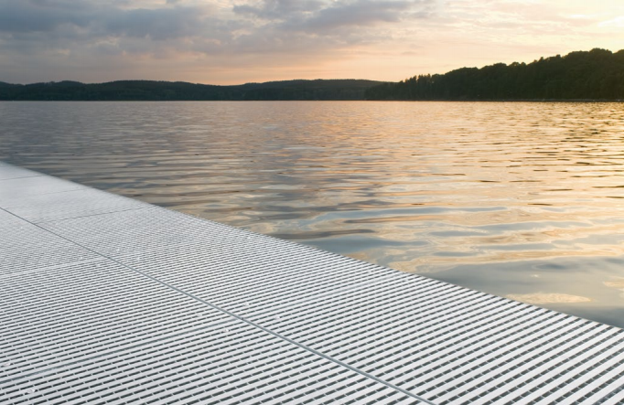
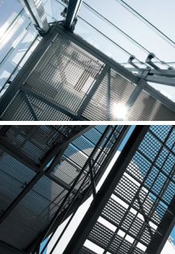
STAIR TREADS AND SPECIAL
GRATINGS IN USE

PRODUCTS

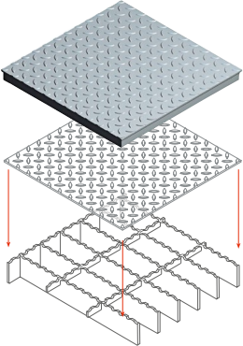

COMBI DECK
Combi decks are gratings with on top welded chequer plates. They combine ideally the advantages of both
products. Chequer plates combine a closed surface
with a slip-resistant effect. Gratings, on the other
hand, have a high load capacity with a low tare weight.

Lichtgitter-Combi deck is used for the industrial sector, e.g. chemical/petrochemical industry, power plants
and cement industry as well as for bulk material and offshore applications.

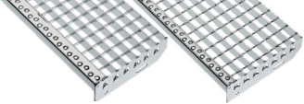
Forge-welded
stairtreads
Pressure locked stairtreads

STAIRTREADS
Lichtgitter customised and standard treads are made in same types and surface structures as the associated landings of pressure-locked gratings, forge-welded
gratings and GRP-Gratings. In this way, a staircase has a continuously consistent look. We achieve optimal
safety of the stairs by introducing perforated nosing.
The treads can be made of steel, stainless steel, aluminium or fibreglass.

SPECIAL GRATINGS
Based on our many years of experience, we are constantly developing new/innovative applica- tion solutions for our customers. Lichtgitter-
Special-gratings are always individually adapted to customer requirements.
Full cell gratings Powder coated gratings Louvres gratings Barefoot gratings
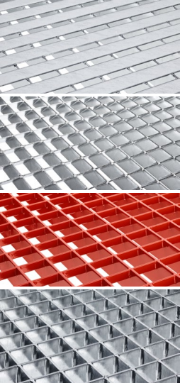

PERFORATED METAL PLANKS

TYPE BZ  The perforated metal plank type BZ “Zahn” offers a high degree of slip resistance due to its serrated surface structure.  For this reason, the BZ plank is especially suitable in those environments, where fats and oils are used. | BZ  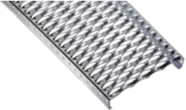
TYPE BP  The type BP is characterised by its smooth surface and high  load-bearing capacity. For this reason, this type of profile metal plank is often used to cover large industrial areas where high  demands are placed on the load capacity. Type BP can also be supplied without studs and is therefore very suitable for use in shelving applications. | BP-Ö  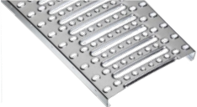
TYPE BN-O  With perforated metal planks, type BN-O “Noppe, offen“ the  bothsided punched holes have a diameter 8 mm and allows an excellent standing stability. Furthermore the drain holes exhibit good drainage. The BN-O grating guarantees a high stability for normal pedestrian traffic. | BN-O  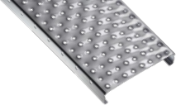
TYPE BN-G  The upwards pressed punched nobs of the perforated metal plank, type BN-G „Noppe, geschlossen“ are closed and offer a high slip  resistance. BN-G gratings are often used in indoor environments and there, where, on the one hand, a closed surface is desired and on the other, good accessibility must be ensured. | BN-G  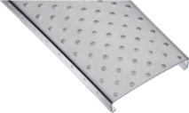

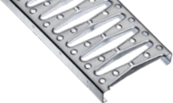
TYPE BR
The perforated metal plank type BR “Raute” is particularly suitable for areas of heavy loads on small contact areas due to its rhomb profile with extra high punching (punched holes 2.5 mm).
BR

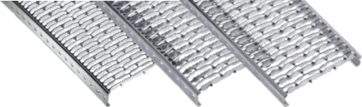
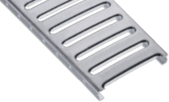
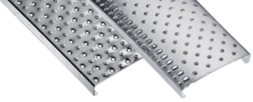
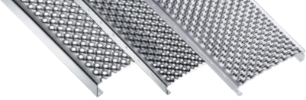
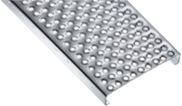
BZ-GV
BZ-GP
BZ-G
BP-ON
BN-OP5
BN-OP
BN-OD
BN-OL
BN-GVI
BN-GA
PRODUCTS
MODELS
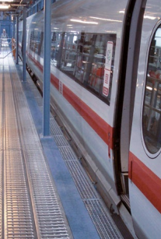
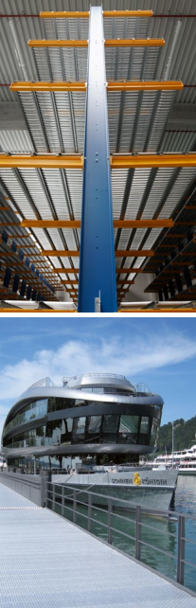
PERFORATED METAL PLANKS
IN USE

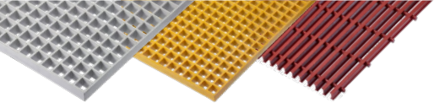

GRP pultruded
GRP yellow
GRP
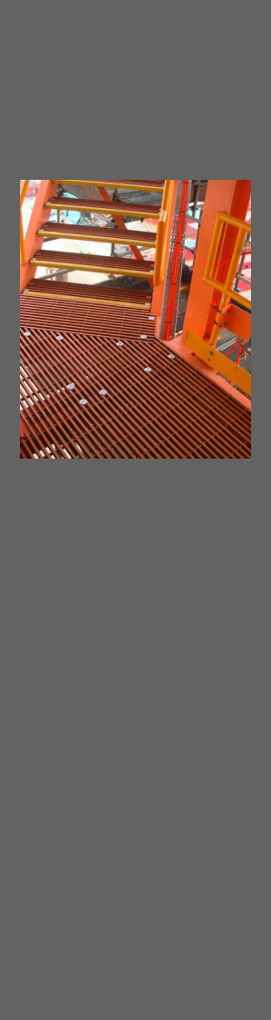
APPLICATION OF GRP-PRODUCTS
IN THE OFFSHORE SECTOR AND
INDUSTRY
GRP PRODUCTS

MOULDED GRP-GRATINGS
Moulded GRP-gratings are produced in a negative mould. Depend- ing on the grating type, height, pitch and bar width, the appropriate mould is selected. The glass fibres are woven in a bond into the
form. The number and position of the glass fibres is determined for each type. The resin mix is produced in a mixing tool.
Their special advantage: Their weatherproof material means they require virtually no maintenance. In addition to our standard
panels, we produce many other types of GRP gratings in a variety of sizes and colours.

PULTRUDED GRP-GRATINGS
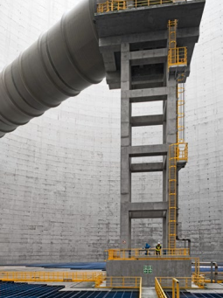
Pultruded GRP gratings are easy to install, highly durable and dimensionally stable to withstand extreme conditions.

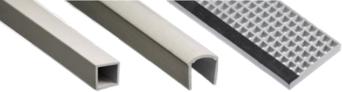
Stairtread
Handrail profile
Square spar profile
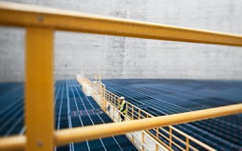
MORE GRP-PRODUCTS
GRP structures, GRP railings, GRP ladders and GRP profiles are also part of the Lichtgitter Group‘s product range.

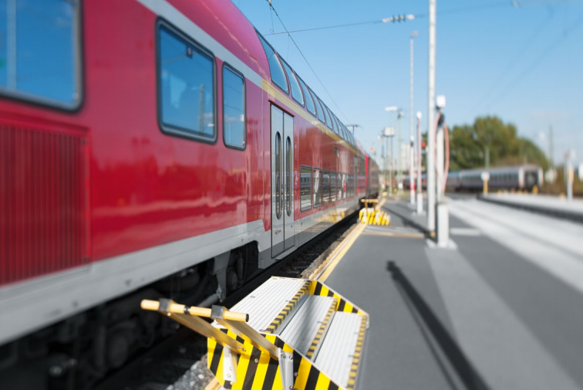
PRODUCTS
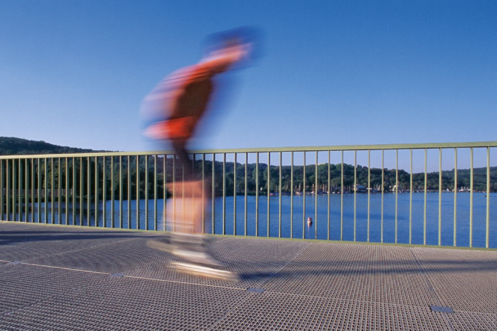
GRP PRODUCTS IN USE

SPIRAL STAIRCASES

TYPE LG STANDARD
We manufacture the spiral staircases, type LG Standard in a hot-dip galvanized version according to DIN EN ISO 1461.
Our modular system is primarily used in the construction of
one-to two-storey staircases in industrial construction, but is also used in the private sector. Diameters up to 2,000 mm can be realised.

TYPE LG SPEZIAL
We manufacture the spiral staircases, type LG in a hot-dip
galvanized version according to DIN EN ISO 1461. This version of the staircase is characterised by the flexibility in height and diameter. This construction is used, among other things, as an escape staircase in multi-storey buildings, as platform access in industrial construction, as well as in the private sector.

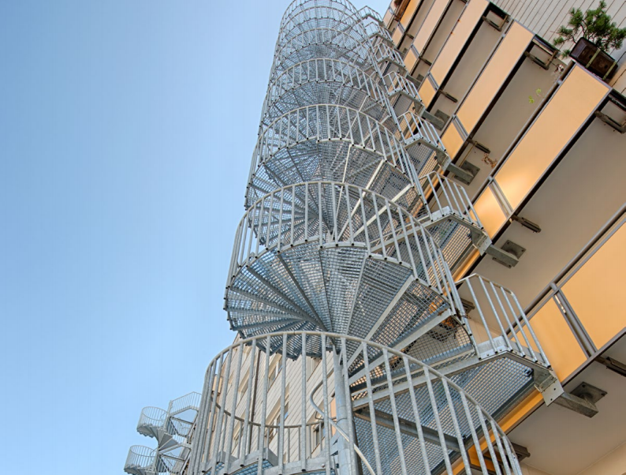

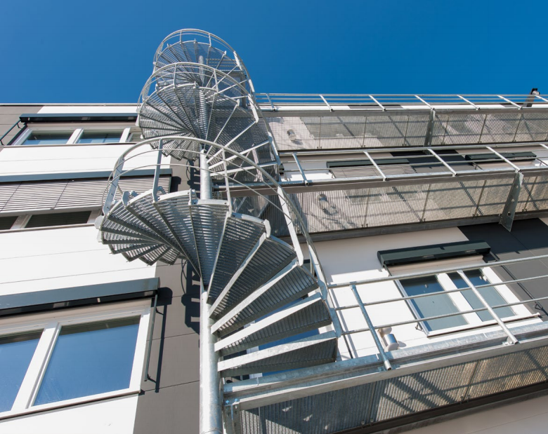

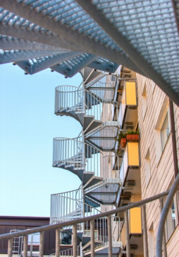
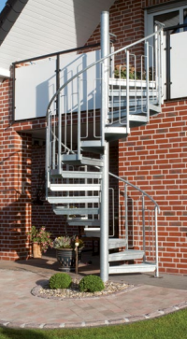

SPIRAL STAIRCASES
IN USE
PRODUCTS

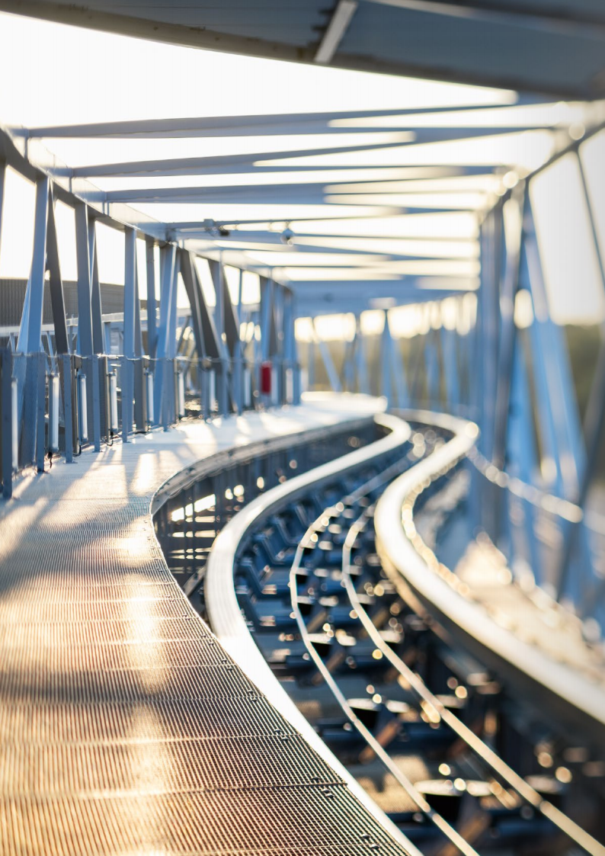

APPLICATIONS
APPLICATIONS

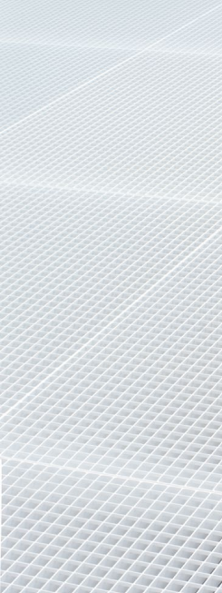

ARCHITECTURE

There are no limits to the use of gratings.

Their functionality and aesthetics allow them to be used as a decora- tive facade covering, a suspended ceiling or for sun protection.

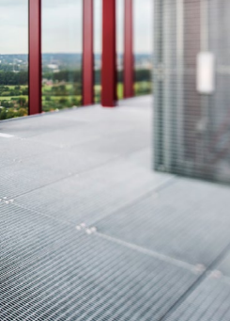
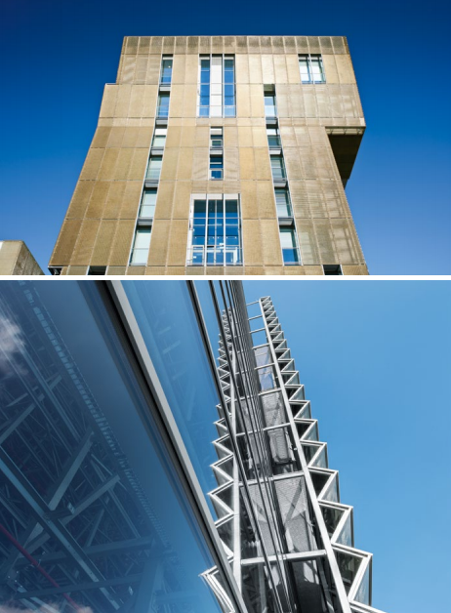

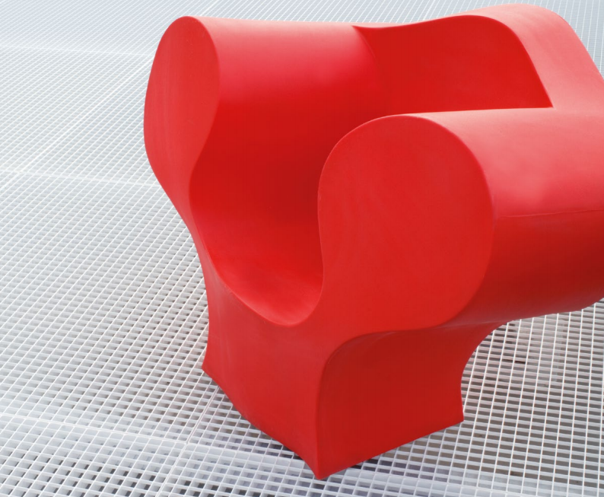
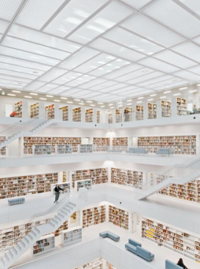
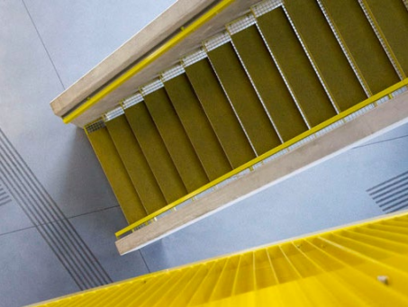
APPLICATIONS

MODELS

FLUSH FITTING SOLUTIONS

1. ANGLED Z-PROFILE
• binding in direction of cross bar standardized with Z-Profile 50/21/12/2 mm as angled bracket
+ optimum utilization of the height

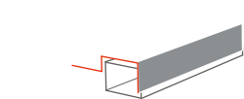

3. ZU-PROFILE
• binding in direction of cross bar with ZU-Profile 20/70/20/12/2 mm (alternative with 40 mm
edging)
+ additional safety by locking at the supports

OVERLAY SOLUTIONS

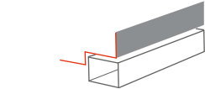

2. BACK STOP
• binding in direction of cross bar standardized with Z-Profile 50/21/12/2 mm and additional upstand as back stop
+ sliding goods are prevented

3. WITH FIRE BAFFLES
• binding in direction of cross bar standardized with Z-Profile and fire baffles
+ higher fire safety (prevents chimney effect)

different dimensions of profiles, notches and prefabrications are possible on request
+

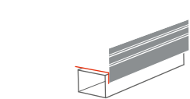

1. LOCKING MECHANISM
• binding in direction of cross bar with a deep
binding bar + 15 mm above bearing bar height as a locking mechanism
+ direct locking mechanism in the rack

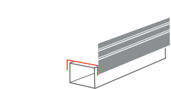

2. DOUBLE LOCKING MECHANISM
• binding bar + 15 mm above bearing bar
• binding in direction of cross bar with deep binding bar generally + 10 mm or 15 mm above bearing bar including 2 cut outs with 56 mm × 15 mm as
additional locking mechanism
+ double locking mechanism

APPLICATIONS
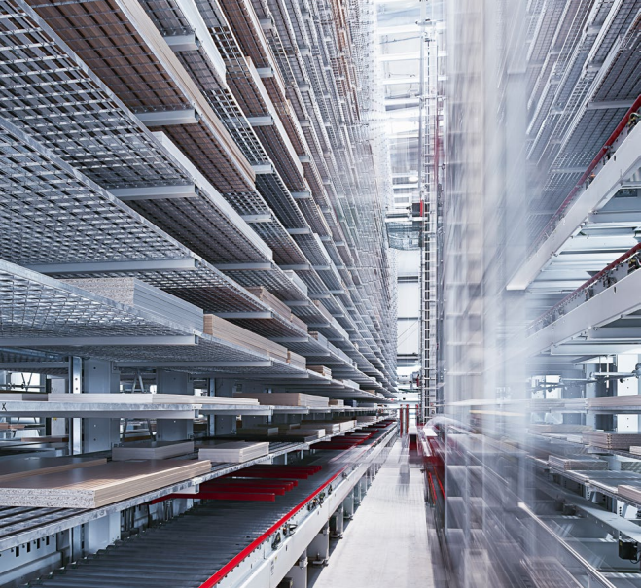
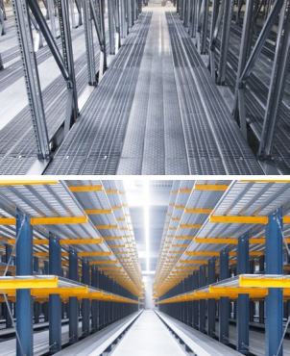

STORAGE AND LOGISTICS

Many years of experience in the use of industrial floor coverings confirms that there are always new applications.
The advantages of using gratings and
perforated metal surfaces in the ware- housing and logistics sector are obvious:
Efficient, safe, quickly mounted, high free cross section= light and water permeabil- ity = increased fire protection.
Our team will help you choose the best product type for your application.

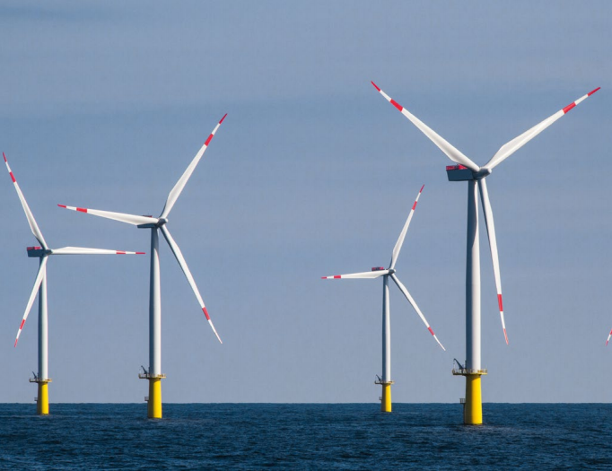
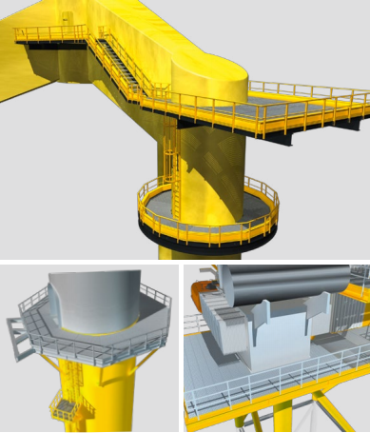

OFFSHORE

True to the motto “Lichtgitter – Every- thing from one source” we offer you the range to meet your wind energy plant
requirements with all types of industrial floor coverings.
Whether platforms of gratings or che- quer plates or transformer coverings
to the point of helihoist, we give you an all-inclusive package backed-up by the established Lichtgitter quality. Due to our long lasting experience you can be assured that we will ensure quality and safety at all levels.
The advantage of our complete offering is that you can discuss everything with
one supplier and that you get all the pro- duct-related services like support during the planning period, preparation of lay- out-drawing, completion of the technical documentation from one source.

APPLICATIONS

Helihoist

Grating air strainer

Internal platforms
Transformer Coverings

GRP Handrails
GRP Vertical ladders

External platforms
GRP Cable tray
GRP-ladder

www.lichtgitter.com

EVERYTHING FROM ONE SOURCE:
forge-welded gratings, pressure-locked gratings,
perforated metal planks, GRP-gratings,
chequer plates, spiral staircases, stairtreads,
ladder rungs, hot-dip galvanising, powder-coating,
steel service.

Lichtgitter GmbH
Siemensstraße 1
D-48703 Stadtlohn
Fon + 49. 25 63.911-0
Mail info@lichtgitter.com

Lichtgitter Blechprofilroste GmbH & Co. KG
Neckarwiesen 20
D-72172 Sulz | Neckar
Fon + 49. 74 54.95 82 -0
Mail sulz@lichtgitter.com

Lichtgitter Treppen
GmbH & Co. KG
Industrie- und Gewerbegebiet 89 DE-16278 Pinnow
Fon + 49. 33 33 5.30 17-0
Mail pinnow@lichtgitter.com

Lichtgitter GFK GmbH & Co. KG
Siemensstraße 1
D-48703 Stadtlohn
Fon + 49. 25 63.911-0
Mail info@lichtgitter.com

